# Unit 5. Decision Making and AI – Lesson 1. Conditional Probability and Fair Game

***Aim:*** What is conditional probability and how do we calculate probability?

**Objectives:** After the lesson, students should be able to:

* Solve conditional probability problems

***References:***

* Unity 5.x Game AI Programming Cookbook, Palacios
* Cornell University, AI and Game Programming, Conditional Probability

<http://www.math.cornell.edu/~mec/2008-2009/TianyiZheng/Conditional.html>

* Online probability and math resources
  + <http://www.onlinemathlearning.com/conditional-probability.html>
  + <http://www.shodor.org/interactivate/lessons/ConditionalProb/>
  + <http://nrich.maths.org/public/leg.php?code=-76>

**CLASS PROCEDURE:**

***Do Now:***

1. You meet a man, and he told you he has two kids. What is the probability for the man to have two sons?
2. You meet a man with his son. The man told you he has exactly two kids. What is the probability for the man to have two sons?

***Class Discussion / Presentation:*** Diagrams to describe conditional probabilities

Here are some diagrams describing conditional probabilities in a visual way:

1. Tree diagram:

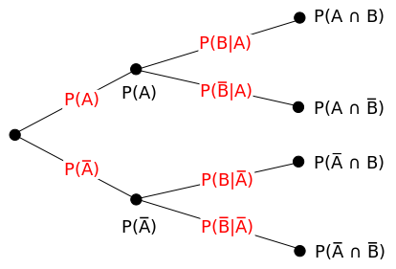

Example:

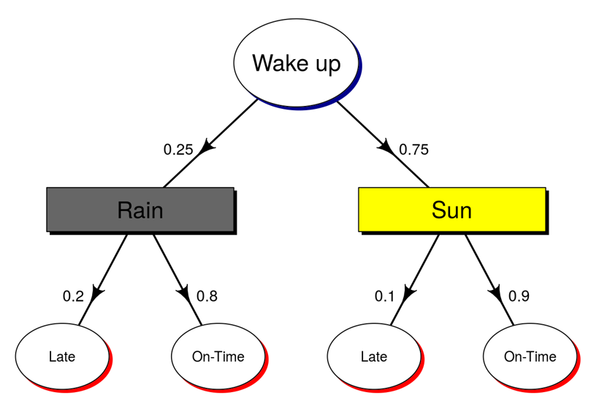

1. Pie diagram:

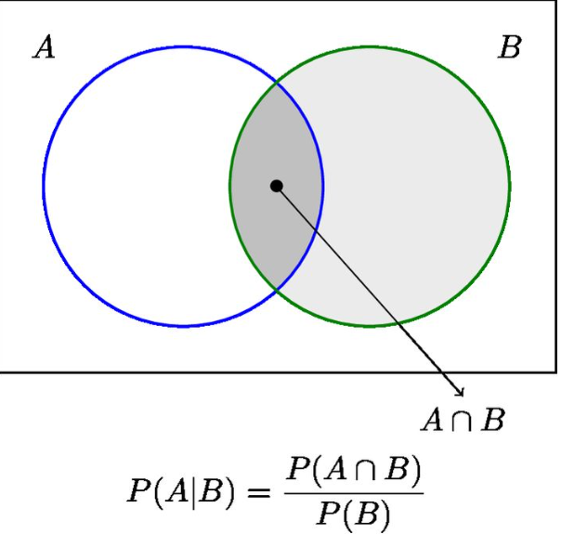

Example:

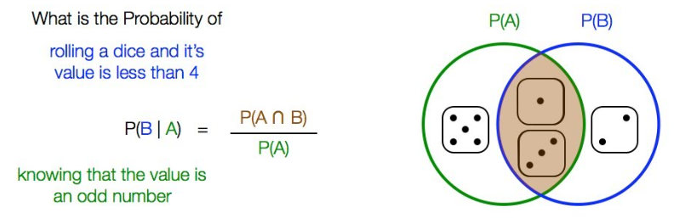

In your Board Game project, did you use conditional probabilities? Did you use any diagram to help you design the AI if you used conditional probability?

***Pair – sharing Activity #1:***

Go to <http://setosa.io/conditional/>,

try the simulation. Do you think the simulation can help you to visualize conditional probabilities? Why and why not?

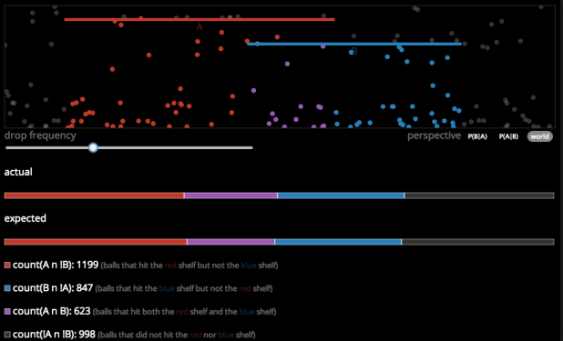

You can drag the red and blue bars to change the lengths of the bars.

***Pair – sharing Activity #2:*** Horse racing with two dice.

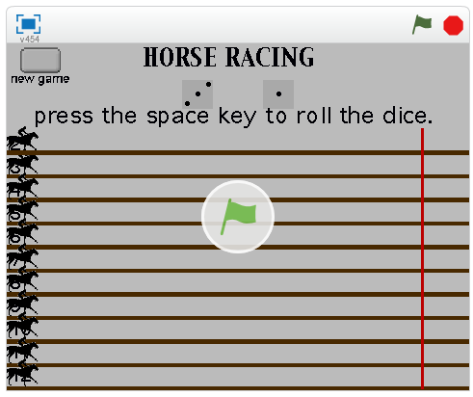

Here’s the link to the simulation:

<https://scratch.mit.edu/projects/743714/>

1. Work with your partner, calculate the winning probability for each horse.
2. Is this a fair game? Why?
3. How do we define fair and unfair?
4. When you design a game, do you want to make your game fair or unfair?
5. Have we seen any fair game and unfair game in the Board Game AI project presentation?

***Pair – sharing Activity:***

Continue working on your midyear project. Prototype (basic module including graphic assets, music assets, basic UI and basic scene set up due: Friday, December 13th)